From spearheading WMAS technology to supporting e-ATA Carnet – Sennheiser goes above and beyond advocating for live entertainment
The audio specialist celebrates key milestones that have a direct impact on the live events industry, contributing to the improved efficiency of wireless microphone operations

Marlow, 20 March 2024 – February marked a significant month for the live entertainment sector for several reasons. Five and a half years after filing a Petition for Rulemaking with the Federal Communications Commission (FCC), requesting a modification in the bandwidth limit specified for wireless microphones, last month Sennheiser marked the FCC’s approval of a change in its regulations. This approval now permits the operation of Wireless Multichannel Audio Systems (WMAS) in the U.S., too, thereby significantly expanding opportunities for wireless microphone users. Another reason that received widespread recognition during the TPi Awards in London, a highlight in the live events industry, was Sennheiser’s collaboration with the event’s organiser TPi Magazine, and Rock-it Cargo, a global logistics specialist. Together, they had two bespoke Sennheiser microphones transported from the US using the first U.S. issued eATA Carnet.

Sennheiser started investigating the potential of wideband technology for wireless multichannel audio systems (WMAS) over ten years ago. By employing various modulation and multiplexing techniques for broadband communication, Sennheiser’s implementation of WMAS technology will allow mics and in-ears to operate in the same TV channel – and in a single bodypack. Overall, spectrum use will become more efficient, while ensuring friendly co-existence with standard narrowband systems.

On the day of the TPi Awards, Sennheiser convened a gathering of industry-leading sound engineers to showcase the potential of WMAS and its impact on the future of live entertainment.

“The event provided an excellent opportunity to bring together key figures in our industry, presenting WMAS and its immense potential. As a company, we are passionate about engaging with sound engineers and welcome anyone interested in reaching out for a conversation with us,” says Kevin Gwyther-Brown, Business Development Manager at Sennheiser.

After the day-time event, Sennheiser proceeded to the TPi Awards, where the team rejoiced in the remarkable achievements of the live touring industry over the past year. Sennheiser also proudly sponsored the ‘Favourite Sound Rental Company’ award, which was won by Adlib.

Sennheiser proudly sponsored the 'Favourite Sound Rental Company' category at TPi Awards, which was won by Adlib Audio.  Picture from left to right: Kevin Gwyther-Brown – Business Development Manager, Sennheiser, Leah Coyle – Account Handler, Adlib, Dave Jones – Director, Adlib, Richy Nicholson – Senior Account Manager, Adlib, Theresa Vondran, Category Market Manager, Sennheiser | 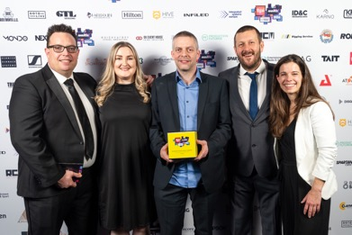

“Among the notable rental companies nominated for the award, we celebrated alongside Adlib, the deserving winners this year,” continues Gwyther-Brown. “Sennheiser maintains a long-standing relationship with Adlib and collaborated with the company when they decided to incorporate our Digital 6000 wireless systems as part of their extensive RF inventory refresh.”

The record-breaking event saw over 1,700 industry professionals gather at Evolution in London, and not only witnessed a multitude of new faces, but also an increased representation of women in the industry. “Diversity continues to be an important focus area both for the industry and the Sennheiser Group worldwide, so it’s great to see the TPi Awards following the same path,” adds Gwyther-Brown.

During the ceremony, two custom-designed Sennheiser EW-DX microphones, customised by Perry Meeks, an Emmy award-winning costume designer known for his work with some of the biggest names in the music industry, including Lady Gaga, Mariah Carey, Janet Jackson, Cher, Paula Abdul, and David Lee Roth, were utilised for awards hosts and presenters. The microphones arrived in the UK for the awards ceremony using the first U.S. digital ATA Carnet (eATA Carnet) for a time-critical hand-carry shipment issued and processed by Rock-it Cargo, who worked closely with the United States Council for International Business (USCIB), the US Customs and Border Protection (CBP), the International Chamber of Commerce World Chamber Federation (ICC WCF), as well as the company’s service providers.

The ATA Carnet, often referred to as a ‘passport for goods’, is an international customs document that permits the temporary, duty-free, and tax-free import of commercial goods. ATA Carnets are essential to the success of live event tours, as they provide the ability to clear Customs in over 100 territories expeditiously and efficiently, to make sure production equipment and gear arrives on time and ready for the show.

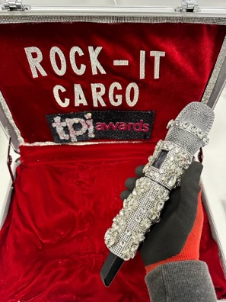 | During the TPi Awards ceremony, two custom-designed Sennheiser EW-DX microphones, decorated by Emmy award-winning costume designer Perry Meeks, were utilised for awards hosts and presenters

“Our team at the Sennheiser US office played a crucial role in facilitating the transportation of those microphones, co-ordinating with Rock-it Cargo to ensure everything was meticulously organised before the shipment to the UK,” explains Gwyther-Brown. “The Sound of Music team in the UK provided the receiver for the wireless mics, enabling a seamless audio performance during the awards ceremony.”

“Having the opportunity to collaborate with such a giant of the live touring industry was huge for Rock-it Cargo,” says Chris Palmer, Managing Director at Rock-it Cargo. “We’ve moved Sennheiser equipment around the world for over 40 years for our clients, and to finally be able to work directly with this company on something so special was a real honour.”

Anticipating the future, Gwyther-Brown concludes: “As we navigate through these exciting times, witnessing the evolution of Sennheiser’s implementation of WMAS technology stands out as a significant milestone, deserving of industry-wide celebration. We are thrilled to share the news and potential for this technology with our industry colleagues. If you’re an engineer and looking to find out more and stay connected, please don’t hesitate to reach out!”

The images accompanying this media release and additional photos can be downloaded here.

About the Sennheiser brand
We live and breathe audio. We are driven by the passion to create audio solutions that make a difference. Building the future of audio and bringing remarkable sound experiences to our customers – this is what the Sennheiser brand has represented for more than 75 years. While professional audio solutions such as microphones, meeting solutions, streaming technologies and monitoring systems are part of the business of Sennheiser electronic GmbH & Co. KG, the business with consumer devices such as headphones, soundbars and speech-enhanced hearables is operated by Sonova Holding AG under the license of Sennheiser.

www.sennheiser.com
www.sennheiser-hearing.com

Global Pro Audio Press Contact
Stephanie Schmidt
stephanie.schmidt@sennheiser.com
+49 (5130) 600 – 1275

